Analysis of Heat Transfer Problems
with the Finite Element Method (FEM)

Bauhaus-Universität Weimar, Informatik im Bauwesen

2009
Contents

1 Formulation of the FEM Solution 4
1.1 Finite Element Approximation for Heat Transfer 4
1.2 Linear 2-Node Elements for Stationary Heat Transfer 7
1.3 Linear 3-Node Elements for Stationary Heat Transfer 9
1.4 Linear 4-Node Elements for Stationary Heat Transfer 11
1.5 Linear 8-Node Elements in 3D for Stationary Heat Transfer 13

Heat Transfer Problems
with the Finite Element Method (FEM)

Formulation of the FEM Solution
The analysis of problems in heat conduction consists of the Finite Element approximation of the system equations with a corresponding formulation of the element equations, the influences on the model (loads), the constitutive relations (material properties) and the external support conditions.
Furthermore, a specific element must be chosen that is appropriate for the problem to be solved defining the geometry of the problem (element geometry) and the element characteristics for the model.

Finite Element Approximation for Heat Transfer
The differential form of the system equation governing the stationary heat transfer of a two-dimensional continuum is given as follows (see for example: [1], [2]):
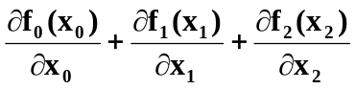 = q for all 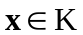
or div f = q for all
where the heat balance in a body is described by vector f for the heat state in a body and by vector q for the heat flow at the boundaries.
Temperature gradient g can be calculated by the partial derivatives of the temperature T:
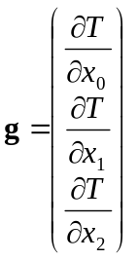
According to the mathematical definition of a gradient this equation can be written as:
g = grad T for all
The relation between the heat state and the temperature gradient is defined by linear constitutive conditions with the definition that heat flows from regions with higher temperature to regions with lower temperature.
f = -C g for all
with: C = 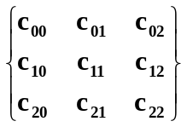 heat conductivity matrix
cij = cij(x) in 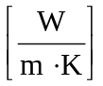 heat conductivity coefficient at position
The relation between heat state and heat flow through any cross section with normal n at point x is defined by:
q = n^{T} f where n is the cross section normal vector
The integral form of the system equation governing the stationary heat transfer of a two-dimensional continuum is given as follows (see for example: [3]):
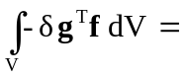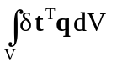- 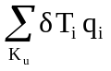- 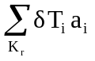
with: V volume of the body, 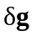variation of temperature gradient, f internal heat state
volumetric influences, 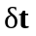 variation of temperature within an element, q prescribed heat flow per unit of volume
nodal influences, K_{u} set of unrestrained nodes subjected to external influences (heat flow q), 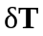is the variation of temperatures at the set of nodes K_{u}, q_{i} values of specified (known) external influences (heat flow) on set of nodes K_{u}
system reactions (support), K_{r} set of restrained nodes with prescribed system values (temperature T), a_{i} unknown support conditions (heat stream) resulting from prescribed temperatures at set of nodes K_{r}.
Substituting the constitutive equations into the system equations above results in
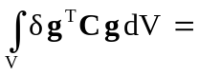- -

Discretization over the volume results in two sums of element integrals V_{e} over all elements:
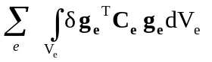= 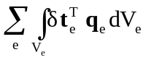- -
Element temperatures and heat streams are conventionally approximated via element shape function expressions S_{e} which may assume different forms depending on the choice of element:
t ≅ 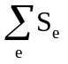 T_{e} with: T_{e} element vector of nodal temperatures
q ≅ q_{e} with: q_{e} element vector of nodal heat flow
The temperature gradient is defined by the equation
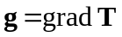
with: 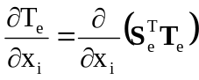
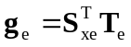
for linear isotropic material the heat conductivity matrix is defined by
C_{e} = 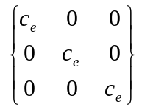= c_{e} * I
where: c_{e} is the element conductivity which is assumed to be constant and isotropic
Thus, the internal heat flow in a isotropic body is defined by
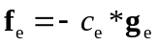 = 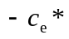 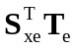
Substituting this information into the system equation above results in the following set of equations for a general formulation of stationary hat transfer:
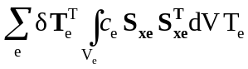= 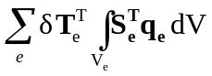 - - 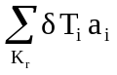
k_{e} p_{ve} p_{ue} q_{re}
Depending on the type of elements and interpolation functions chosen this will result in a different set of linear equations of the form:
K_{s}T_{s} = p_{s} - q_{s}
The system matrix K_{s} is multiplied by the vector of nodal temperatures T_{s} referred to as primal vector of system unknowns or known (prescribed) values of system variables T.
The Right-Hand-Side (RHS) consists of the external influences on the system referred to as load vector p_{s} with specified (known) values of heat streams inside the body and at specific nodes
and of the support conditions on the system q_{s} referred to as dual system vector with unknown values of heat streams resulting from predefined temperatures at restrained boundary nodes and all other values of the dual vector equal to 0.

Linear 2-Node Elements for Stationary Heat Transfer
Generally, a variety of elements and approximation functions may be chosen for approximating the geometry of the model and the functional behaviour of the model.
For the purposes of this text, linear 1-dimensional elements (heat rods) were chosen to approximate the element geometry and linear functions for the element characteristics in stationary heat transfer.
Physical problems of stationary heat transfer are defined by a single degree of freedom per node, i.e. the temperatures at the nodes (T_{e(i)}, T_{e(j)}) as primal unknowns).
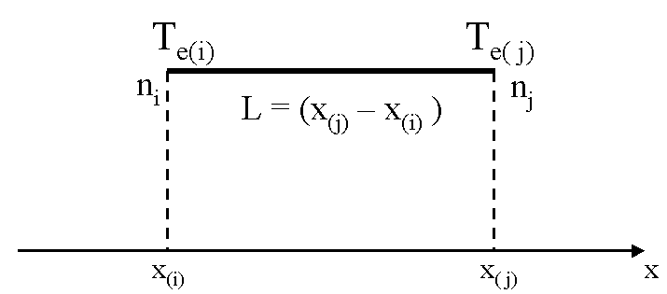

global coordinates
The approximation of temperatures and heat streams within an element is accomplished by the following linear interpolation using the shape function in z for nodes (i,j):
t(z)_{e} = 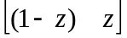 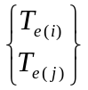
t(z)_{e} = s_{e}(z)^{T} T_{e}
The topological mapping of normalized onto corresponding global coordinates is defined by matrix R_{e} which maps local field variables T_{e} at nodes (i, j) to global field variables T_{s}. This mapping is implicitly handled by the FEM Framework on the basis of the system indices generated for all nodal degrees of freedom. It does not need to be performed by the user. System indices refer to the global degrees of freedom associated with each node (e.g. T_{i}) and elements with normalized coordinates are generated with reference to these nodes.
= 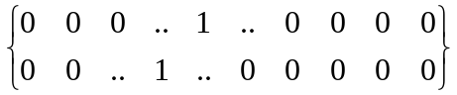 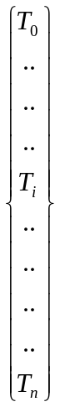
T_{e} = R_{e} T_{s}

Element matrices are determined by evaluating for each element the integrals:
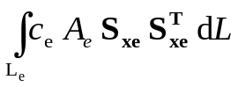
The shape function derivatives and the element geometry in general are totally independent of a specific application and are thus documented in the FEM-Framework documentation [4] and incorporated into the FEM-Framework implementation.

The element shape function derivative S_{xe} and the value of the determinant are independent of the normalized coordinates z. The element conductivity c_{e} and cross sectional area A_{e} were also assumed to be constant. The integrals can therefore be evaluated analytically for each element.
k_{e} = 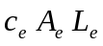S_{xe} S_{xe}^{T} = 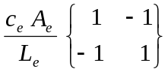

Linear 3-Node Elements for Stationary Heat Transfer
Generally, a variety of elements and approximation functions may be chosen for approximating the geometry of the model and the functional behaviour of the model.
For the purposes of this text, triangular elements were chosen to approximate the element geometry and linear functions for the element characteristics in stationary heat transfer. The element geometry is defined by deriving the implementation from the abstract implementation AbstractLinear3Node2D.
Physical problems of stationary heat transfer are defined by a single degree of freedom per node, i.e. the temperatures at the nodes (T_{e(i)}, T_{e(j)}, T_{e(k)}) as primal unknowns).
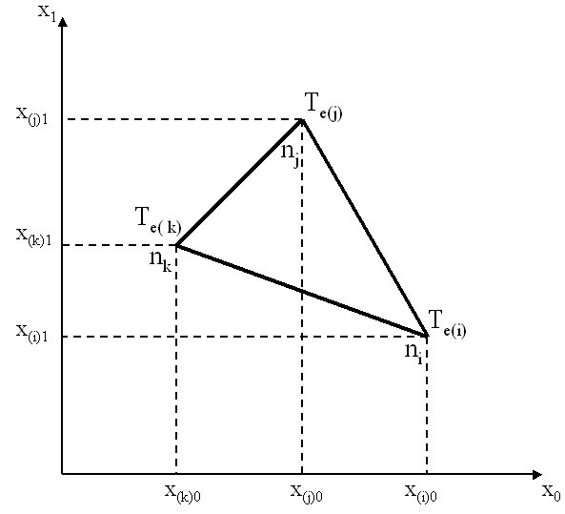  global coordinates | 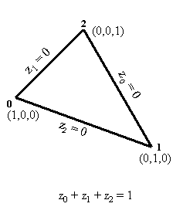  normalized triangular coordinates
The approximation of temperatures and heat streams within an element is accomplished by the following linear interpolation using the shape functions in triangular coordinates (z₀, z₁, z₂) for all three nodes (i,j,k):
t(z)_{e} = 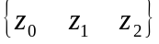 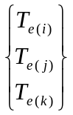
t(z)_{e} = s_{e}(z)^{T} T_{e}
The topological mapping of normalized onto corresponding global coordinates is defined by matrix R_{e} which maps local field variables T_{e} at nodes (i, j, k) to global field variables T_{s}. This mapping is implicitly handled by the FEM Framework on the basis of the system indices generated for all nodal degrees of freedom. It does not need to be performed by the user. System indices refer to the global degrees of freedom associated with each node (e.g. T_{i}) and elements with normalized coordinates are generated with reference to these nodes.
= 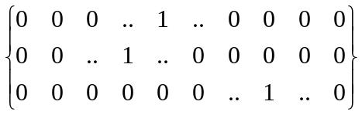
T_{e} = R_{e} T_{s}

Element matrices are determined by evaluating for each element the integrals:
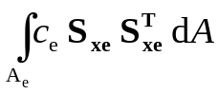
In case of a linear triangle, the element shape function derivatives S_{xe} and the value of the determinant are independent of the normalized coordinates z_{i} and thus constant at each point within the triangle. The element conductivity c_{e} was also assumed to be constant. The integrals can therefore be evaluated analytically for each element.
k_{e} = c_{e} S_{xe} S^{T}_{xe} * area_{e} = 0.5 * det X_{z} c_{e} * S_{xe} S^{T}_{xe}
In general, integration of element matrices is accomplished numerically, i.e. by evaluating the individual contributions at each Gauss point, by summing up contributions for all Gauss points and by multiplying the results with the corresponding Gauss weights. Thus, evaluation at three Gauss point and application of Gauss weight 1/3 would result in the same constant value of the shape function derivatives and the determinant.

Linear 4-Node Elements for Stationary Heat Transfer
Elements with four nodes and a linear variation of coordinate functions may be chosen to approximate the element geometry and element characteristics in stationary heat transfer. The element geometry is defined by deriving the implementation from the abstract implementation AbstractLinear4Node2D.
Physical problems of stationary heat transfer are defined by a single degree of freedom per node, i.e. the temperatures at the nodes (T_{e(i)}, T_{e(j)}, T_{e(k)}, T_{e(l)})as primal unknowns).
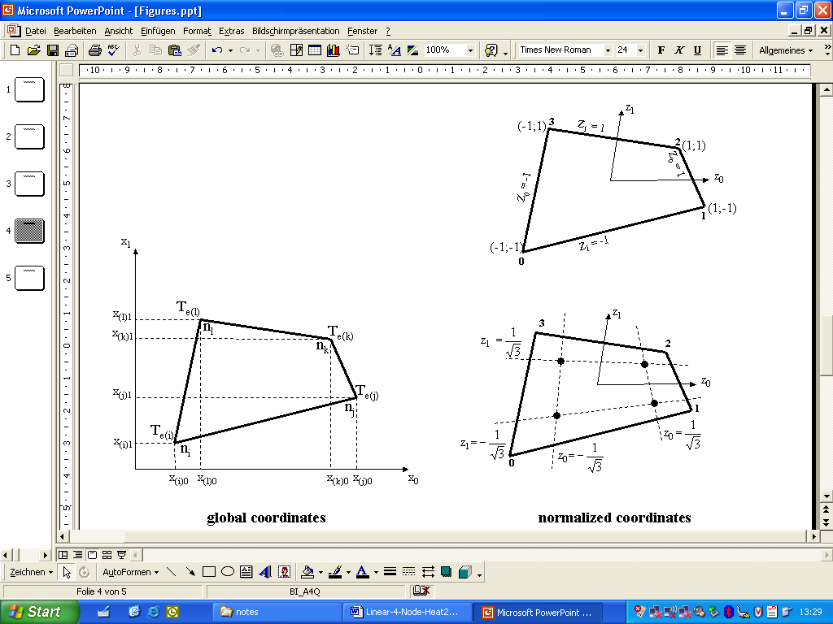  global coordinates | normalized coordinates
The approximation of temperatures and heat streams within an element is accomplished by linear interpolation using the shape functions in global coordinates (z₀, z₁) for all four nodes (0,1, 2, 3) in both directions (0,1):
t(z)_{e} = 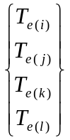
t(z)_{e} = s_{e}(z)^{T} T_{e}
The topological mapping of normalized onto corresponding global coordinates is defined by matrix R_{e} which maps local field variables T_{e} at nodes (i, j, k) to global field variables T_{s}. This mapping is implicitly handled by the FEM Framework on the basis of the system indices generated for all nodal degrees of freedom. It does not need to be performed by the user. System indices refer to the global degrees of freedom associated with each node (e.g. T_{i}) and elements with normalized coordinates are generated with reference to these nodes.
= 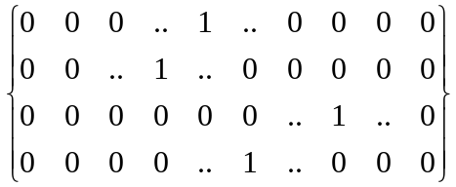
T_{e} = R_{e} T_{s}
Element matrices are determined by evaluating for each element the integrals:
In case of a linear quadrilateral, the element shape function derivatives S_{xe} and the value of the determinant are evaluated numerically by Gaussian integration. For this purpose, the values of matrix S_{xe} are evaluated at corresponding Gauss points and multiplied by associated Gauss weights. Integration over the area of the elements is carried out in normalized coordinates:
dA = dx₀ dx₁ = det X_{z} dz₀ dz₁
Thus, element matrices may be evaluated by the sum over the Gauss points for the product:
k_{e} = 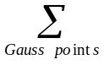c_{e} * S_{xe} * S_{xe}^{T} * det X_{z}
where : c_{e} is constant over the element and
the values of S_{xe} and det X_{z} are evaluated at each Gauss point
For the case of the linear element with 4 nodes, an order of integration of 22 is sufficient. The corresponding Gauss points p(z₀, z₁) and Gauss weights are:
normalized coordinates | with the associated Gauss weights equal to  1.0

Linear 8-Node Elements in 3D for Stationary Heat Transfer
Elements with eight nodes and a linear variation of coordinate functions may be chosen to approximate the element geometry and element characteristics in 3-dimensional stationary heat transfer. The element geometry with the shape function definitions, the shape function derivatives and the Jacobian is defined by deriving the implementation from the abstract implementation AbstractLinear8Node3D.
Physical problems of stationary heat transfer are defined by a single degree of freedom per node, i.e. the temperatures at the nodes (T_{e(i)}, .... T_{e(p)}) as primal unknowns).
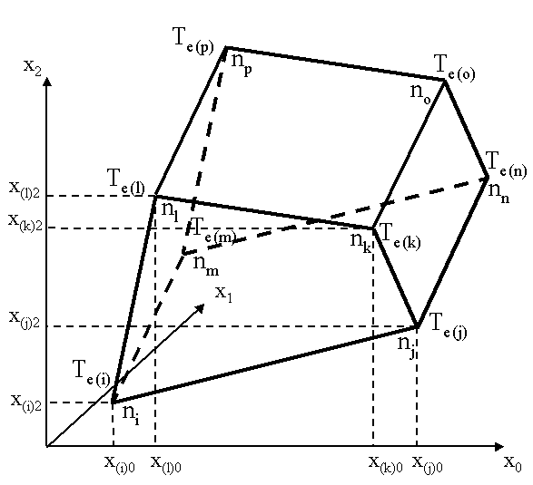  global coordinates | 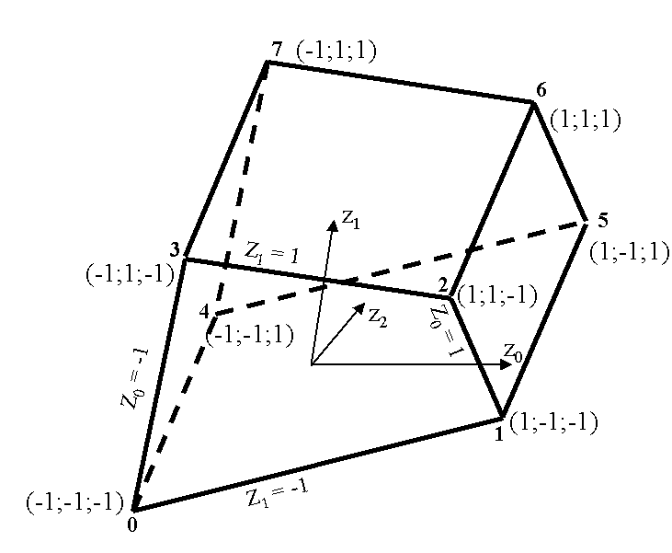  normalized coordinates
The approximation of temperatures and heat streams within an element is accomplished by linear interpolation using the shape functions in global coordinates (z₀, z₁, z₂) for all eight nodes (0 ... 7) in all three directions (0,1,2):
t(z)_{e} = S^{T}_{e} T_{e}
where: T_{e} is the vector of nodal temperatures at 8 nodes in 3 directions (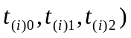 and S^{T}_{e} is the (3*8) matrix of shape function vectors s(z) in all 3 directions
The topological mapping of normalized onto corresponding global coordinates is defined by matrix R_{e} which maps local field variables T_{e} at the 8 nodes (i ... p) to global field variables T_{s}. This mapping is implicitly handled by the FEM Framework on the basis of the system indices generated for all nodal degrees of freedom. It does not need to be performed by the user. System indices refer to the global degrees of freedom associated with each node (e.g. T_{i}) and elements with normalized coordinates are generated with reference to these nodes.
T_{e} = R_{e} T_{s}
Element matrices are determined by evaluating for each element the integrals:
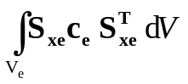
In case of a linear 8-node element, the element shape function derivatives S_{xe} and the value of the determinant are evaluated numerically by Gaussian integration. For this purpose, the values of matrix S_{xe} are evaluated at corresponding Gauss points and multiplied by associated Gauss weights. Integration over the area of the elements is carried out in normalized coordinates:
dV = dx₀ dx₁ dx₂ = det X_{z} dz₀ dz₁ dz₂
Thus, element matrices may be evaluated by the sum over the Gauss points for the product:
k_{e} = S_{xe} * c_{e} * S_{xe}^{T} * det X_{z}
where : c_{e} is a diagonal matrix with the value of conductivity for each direction
and the values of S_{xe} and det X_{z} are evaluated at each Gauss point
For the case of the linear element with 8 nodes, an order of integration of 33x3 is sufficient. The corresponding Gauss points p(z₀, z₁, z₂) are defined in all 3 directions by the 3 normalized coordinates:
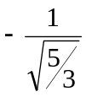 0 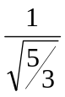
and the corresponding Gauss weights are:
This can be shown for the 3x3 Gauss points in a plane in direction z₂ = :
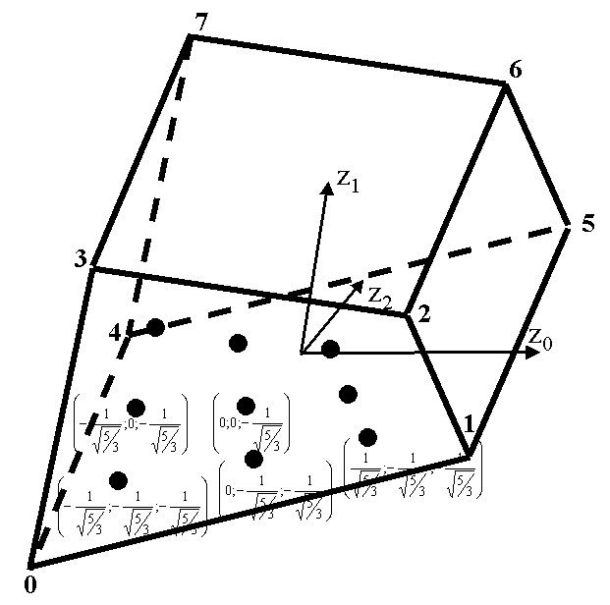  normalized coordinates | with the associated Gauss weights equal to  in both directions

